Assignment 5 Arduino Application

Released Date: Nov 13th
Version 1.0
Format: Name the document in the combination of name、ID and No. of Assignment.
Example: Ping Yi_23_Assignment1.doc
Email the document to “pingy@wxit.edu.cn” before Nov 20th.

Task Design a circuit using a temperature sensor, three LEDs indicate different levels of temperature stages, the detailed information will be displayed on LCD1602. Once the simulated temperature is over the 60 degrees Celsius, then the piezo will give an alarm to indicate overheating.
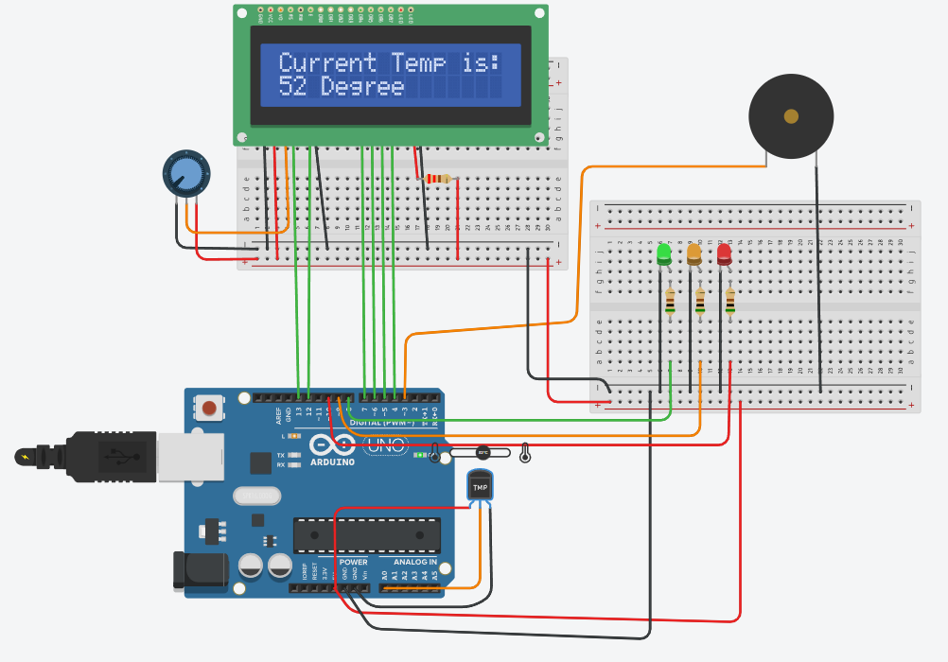
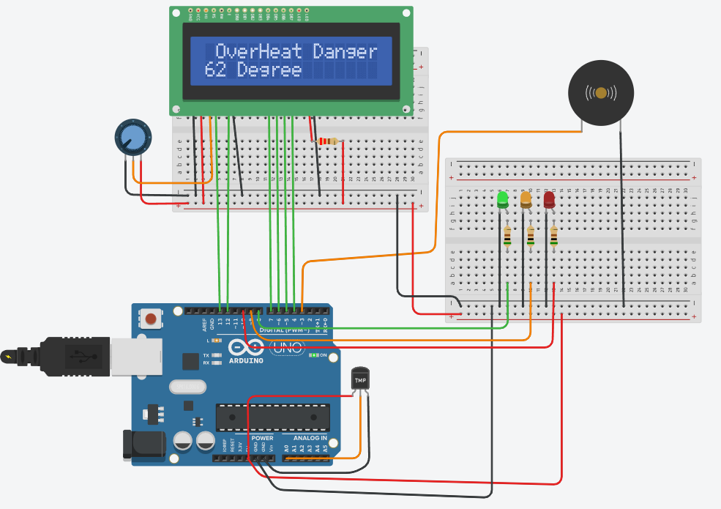
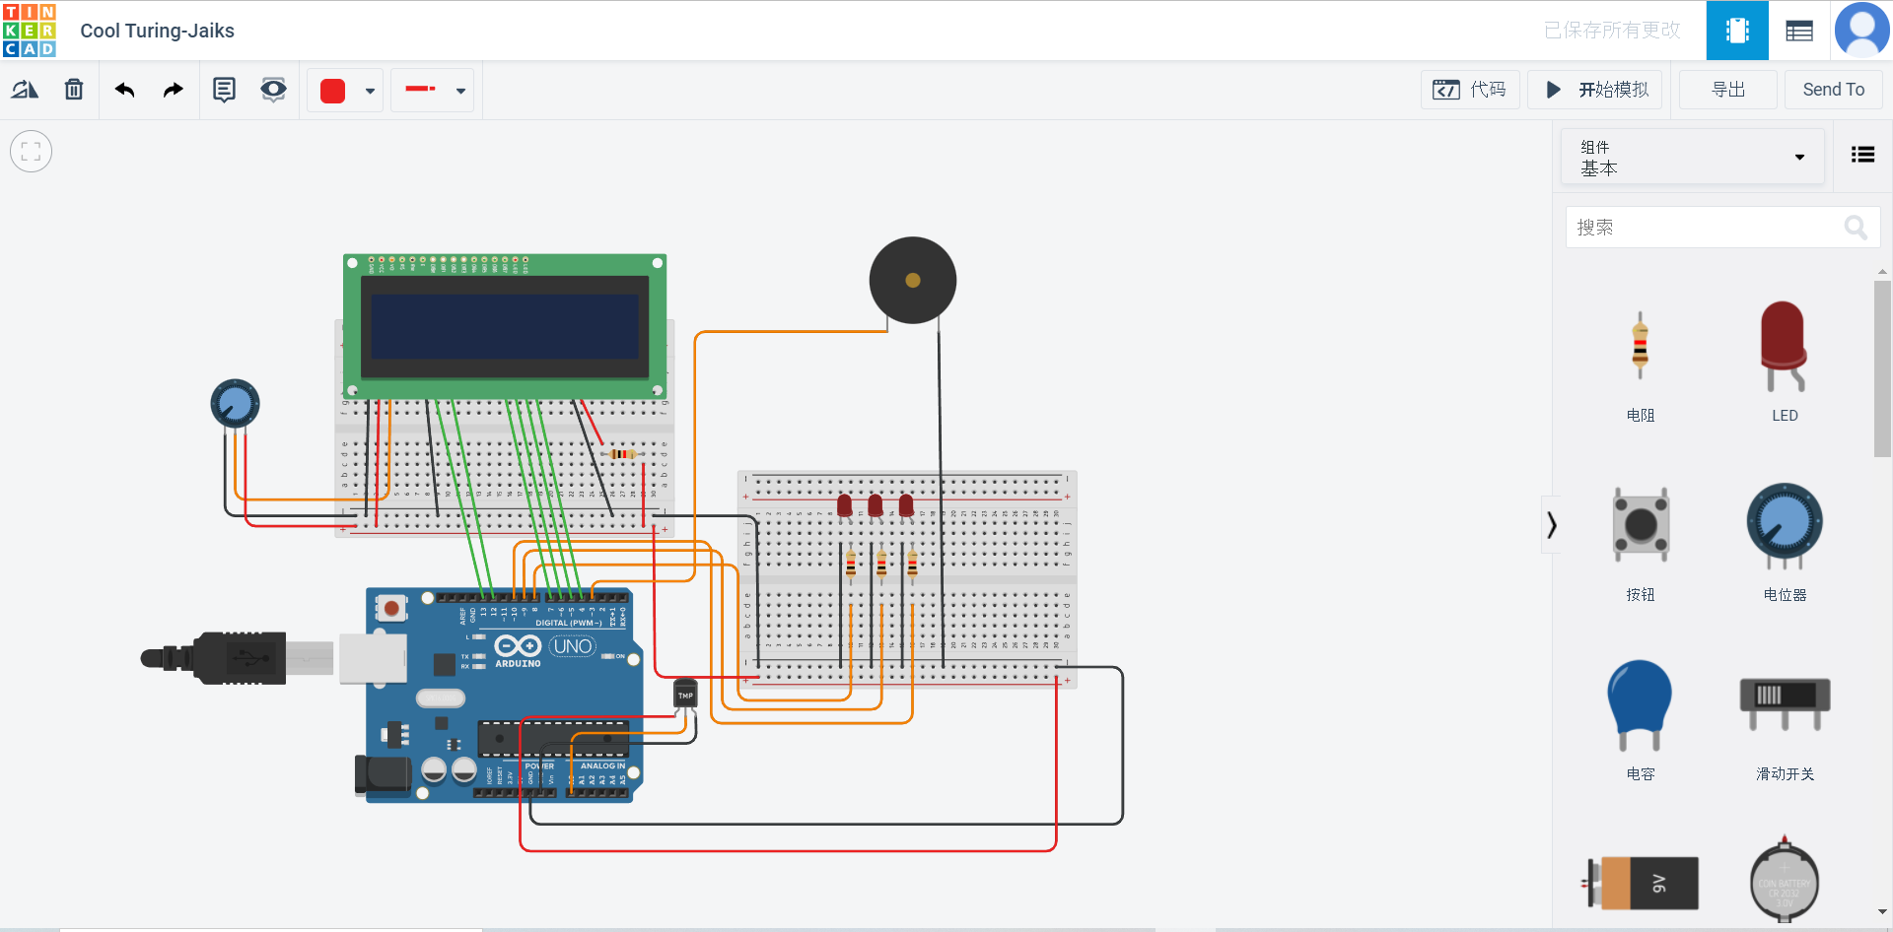
#include <LiquidCrystal.h>
LiquidCrystal lcd(13,12,7,6,5,4);
float celsius = 0;
float fahremheit = 0;
void setup()
{
pinMode(8,OUTPUT);
pinMode(9,OUTPUT);
pinMode(10,OUTPUT);
Serial.begin(9600);
lcd.begin(16,2);
lcd.setCursor(0,0);
lcd.print("Current Temp is:");
}

void loop()
{
celsius=map(((analogRead(A0)-20)*3.04),0,1023,-40,125);
lcd.setCursor(0,1);
lcd.print(celsius);
lcd.setCursor(7,1);
lcd.print("Dergee");

Serial.print(celsius);
Serial.print("C");
Serial.print(fahremheit);
Serial.println("F");

if(celsius<50){
digitalWrite(8,HIGH);
digitalWrite(9,LOW);
digitalWrite(10,LOW);
digitalWrite(3,LOW);
}
if(celsius>=50&&celsius<60){
digitalWrite(8,HIGH);
digitalWrite(9,HIGH);
digitalWrite(10,LOW);
digitalWrite(3,LOW);
}
if(celsius>=60){
digitalWrite(8,HIGH);
digitalWrite(9,HIGH);
digitalWrite(10,HIGH);
digitalWrite(3,HIGH);
}
}

